**Project : Healthcare Teleconsultation System**

**Phase 2: Org Setup & Configuration**

**Org Setup Settings :**

1. Company Information

Setup ----> Company Settings ----> Company information ----> Edit Organization Name ----> Update Default Locale, Default Time Zone, Currency Locale

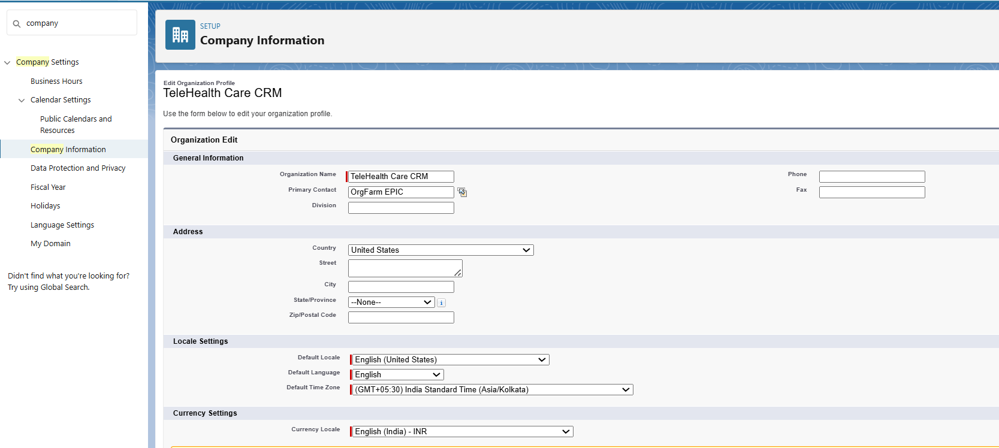

1. Business Hours & Holidays

Setup ----> Business Hours ----> New ----> Create SLA support Hours

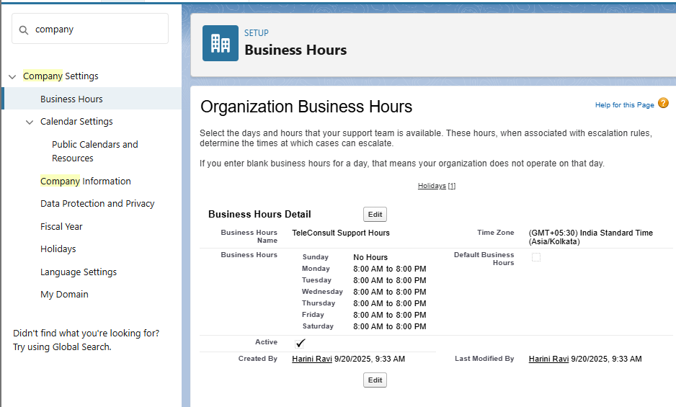

1. Holidays

Setup ----> Holidays ----> Add Holidays

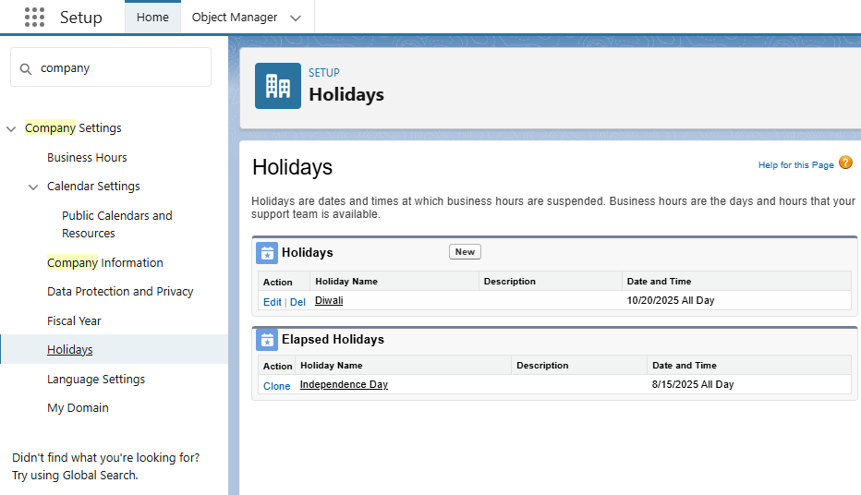

1. Fiscal Year Settings

Setup ----> Fiscal Year ----> Edit Standard Fiscal year

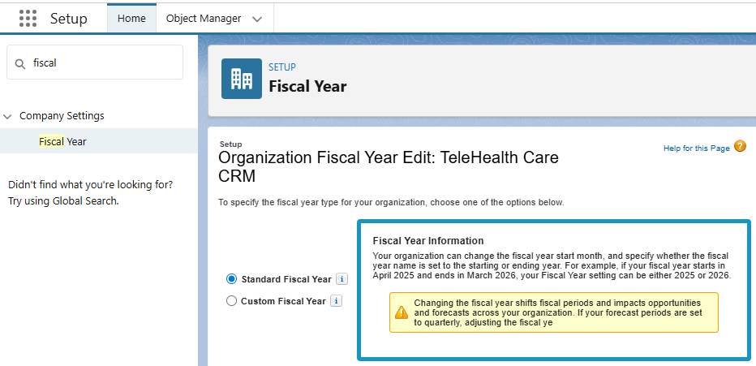

1. Profiles

Setup ----> Users ----> profiles ----> New profile ----> Create Doctor profile, Support Staff, Patient Community

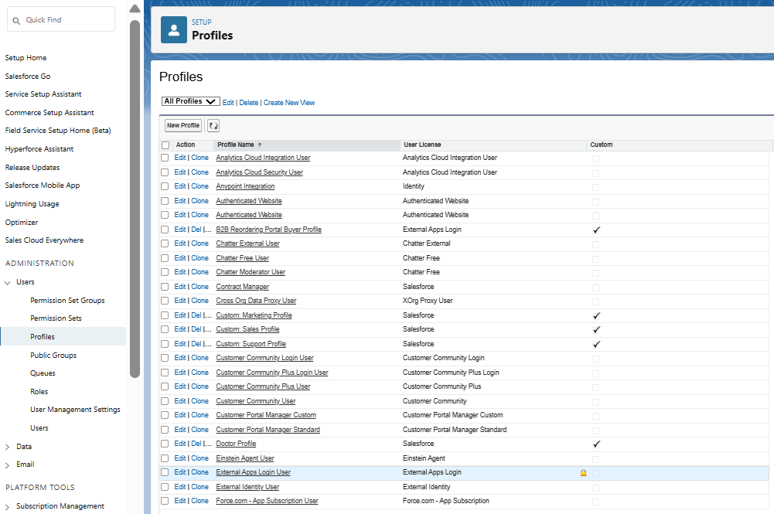

1. Roles

Setup ----> Users ----> Roles ----> Creating the Role Hierarchy ---->

Create Add Role ----> Doctor/Provider, Patient community User, Support staff.

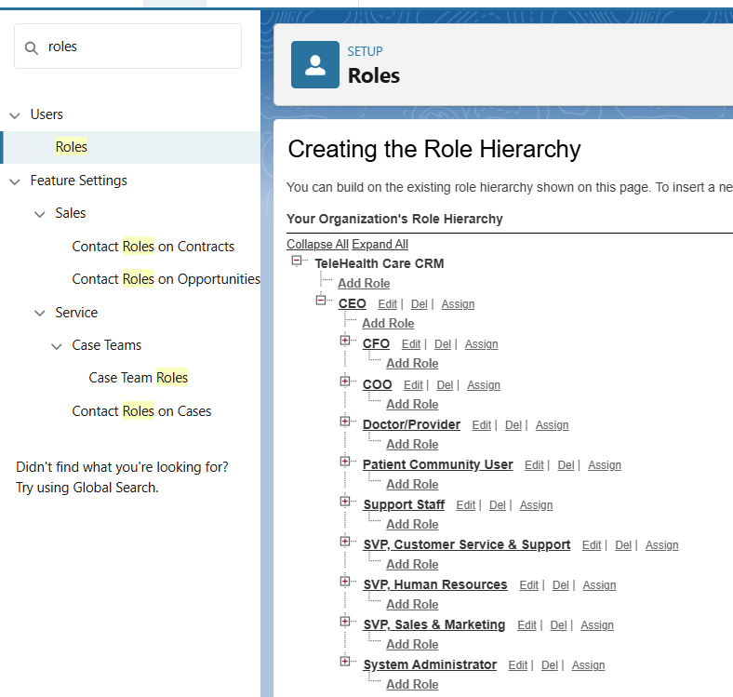

1. Create Users

Setup ----> Users ----> New user ----> Create a test user for each role.

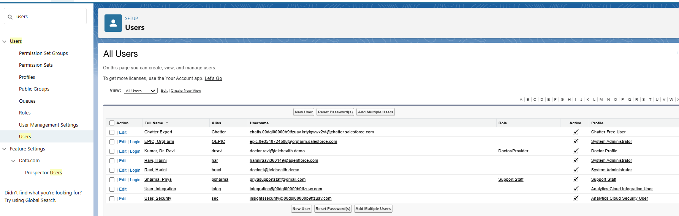

1. Permission Sets

Setup ----> Permission Sets ----> Create new Permission Setup ----> TeleHealth Agent Access

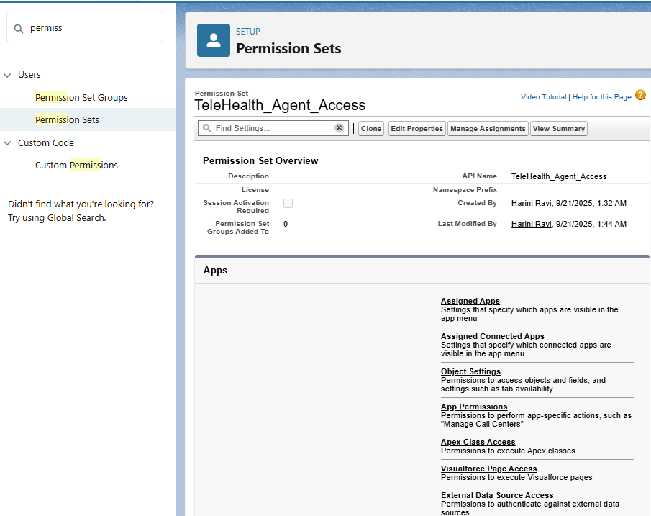

1. Organization-Wide Email Addresses(OWD)

Setup ----> Email ----> OWD ----> Add new Email.

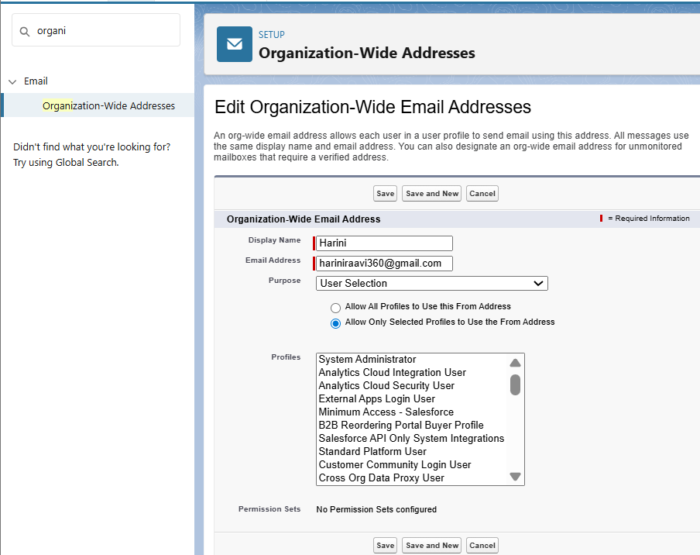

1. Sharing rules

Setup ----> Sharing Settings ----> Create Sharing rules according to each profile type

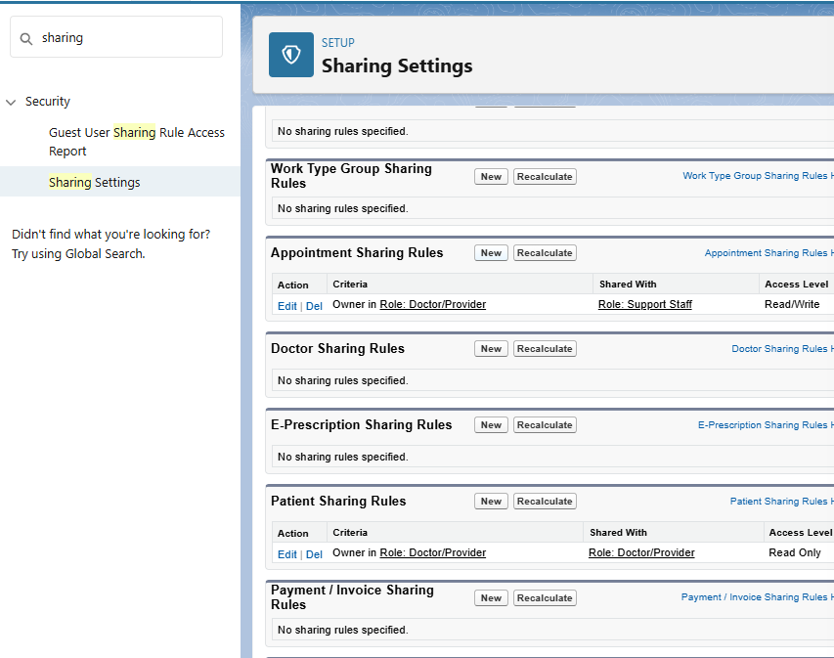

1. Login Access Policies

Setup ----> Security ----> Login Access Policies ----> edit Mange Support options.

